Course Name : Software Engineering
Project Name : POS System
Final Report
- Team Members ( Team 2 ):

1 – Name : Youssef Mohamed Abd El Hamid
Id : 20191613937
2 – Name : Ahmed Hossam El Din Mahrous
Id : 20191566027
3 – Name : Ahmed Hossam El Din Hamamy
Id : 20191613643
4 – Name : Yahia Ousama Mohamed
Id : 20191615496

- Customer Proof:
- Haberdashery Store :-
Customer Name :Hossam El Din Mahrous
Customer Mobile Number : 01223706091
Customer address : 19 Hasbo Street – Moharm Bek

POS System
- What Is POS ?
A POS ( Point of Sale ) is a system that is used for your business that allows your business to accept payments from customers and keep track of sale

- What does POS system do ?
- A customer decides to buy your product or service
- Your POS system calculates that price of the item
- Your customer pays


The Case
In our case the client asked for a system to manage his store the system must contains cashiering system which is a group of small systems all groups together to form one big system helps him .those small systems or services are as following :
- POS System : to track selling process and make it (faster) and record on the system and also pricing catalog merged to this system to help him remember the prices of the goods and print recite
- Stock System : to keep the warehouse organized and goods countable which will make it more easier for him to know which goods are not available or about to sold out and the goods which he have a good stock of it
- Bar Code System : with the help of the POS system he can give all the goods at his store a unique bar code to know which good is sold and when and of course the price will be on the bar code her we managed to make the selling process faster which needed by the client
- Analysis System : the client asked for a system can track his profit percentage along some periods(weeks , months
- Log in System : Different accounts for the owner and the workers with different specifications.

Model
Agile XP Model:
4 Framework must be define :-
1 – Planning
2 – Design
3 – Coding
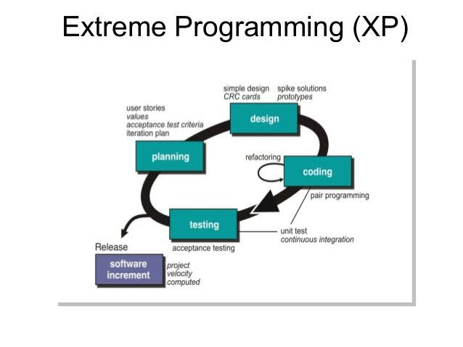
4 – Testing
Why agile Model ?

- where requirements and solutions evolve through collaboration between us , self-organizing, and cross-functional teams.

- Requires customer feedback any time.

- Iterative and Incremental development is at the heart of a cyclic software development process developed in response to the weaknesses of the waterfall model.

- The main advantage of Extreme Programming is that this methodology allows software development companies to save costs and time required for project realization.

Business Requirements
Pos system To track the movement of store revenues and complete the sale process better

User Requirements
- Every month , the owner gets a report on the sale movement
- Employee use this system to complete the sale to the customer

System Requirements

Functional Requirements Non–Functional Requirements
- Functional Requirements:
- Modify accounts : admin add new account with a username and password and store them in the database , also admin can block this account
- Log in : Admin and each employee has an account , They log in into account and verified by Database
Add items : Admin store items in the stock by read its Barcode and determine its price and quantity
- Delete items : Admin delete items from stock
- Update items : Change the price of item
- Make order : by reading bar code from item , system will check this item in the stock to find out its price
- Store order : after reading bar code this item count will be decreased from stock and increased in the sold count
- Void order : remove items from order
- Refund order : return order within 14 day
- Calculate sub total : count each item and multiply it by each price
- Calculate total tax : sum all sub totals
- Print receipt : included name of items, count and total price
- Payment : The customer pays cash
- Analysis and statistics report : Report on all revenues every month to know the most sold items and least sold items

- Non – Functional Requirements:

- Maintainability : to maintain the software system if needed
- Easy to use
- Color blindness : “ Friendly “ it hard to tell the difference between red & green and blue & yellow
- Java language : Java is a high – level , class – based , object – oriented language that is designed to have as few implementation dependencies as possible
- Database : MySQL
- Efficiency : POS system must work at peak performance and time response < 5 seconds & space 1500 Kb
- Usability : is a measure of how well a specific user in a specific context can use a software to achieve a defined goal effectively

System Models

Use case Class Diagram sequence Diagram
- Use Case
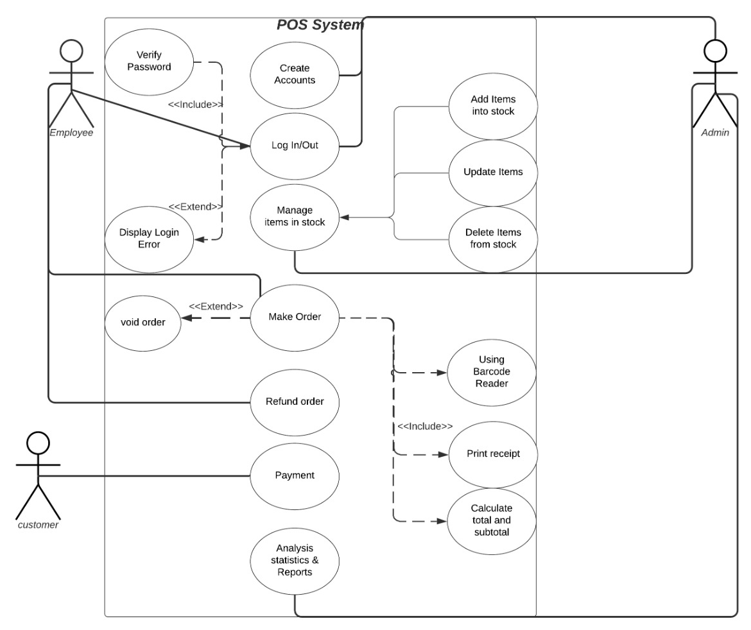
- Class Diagram :
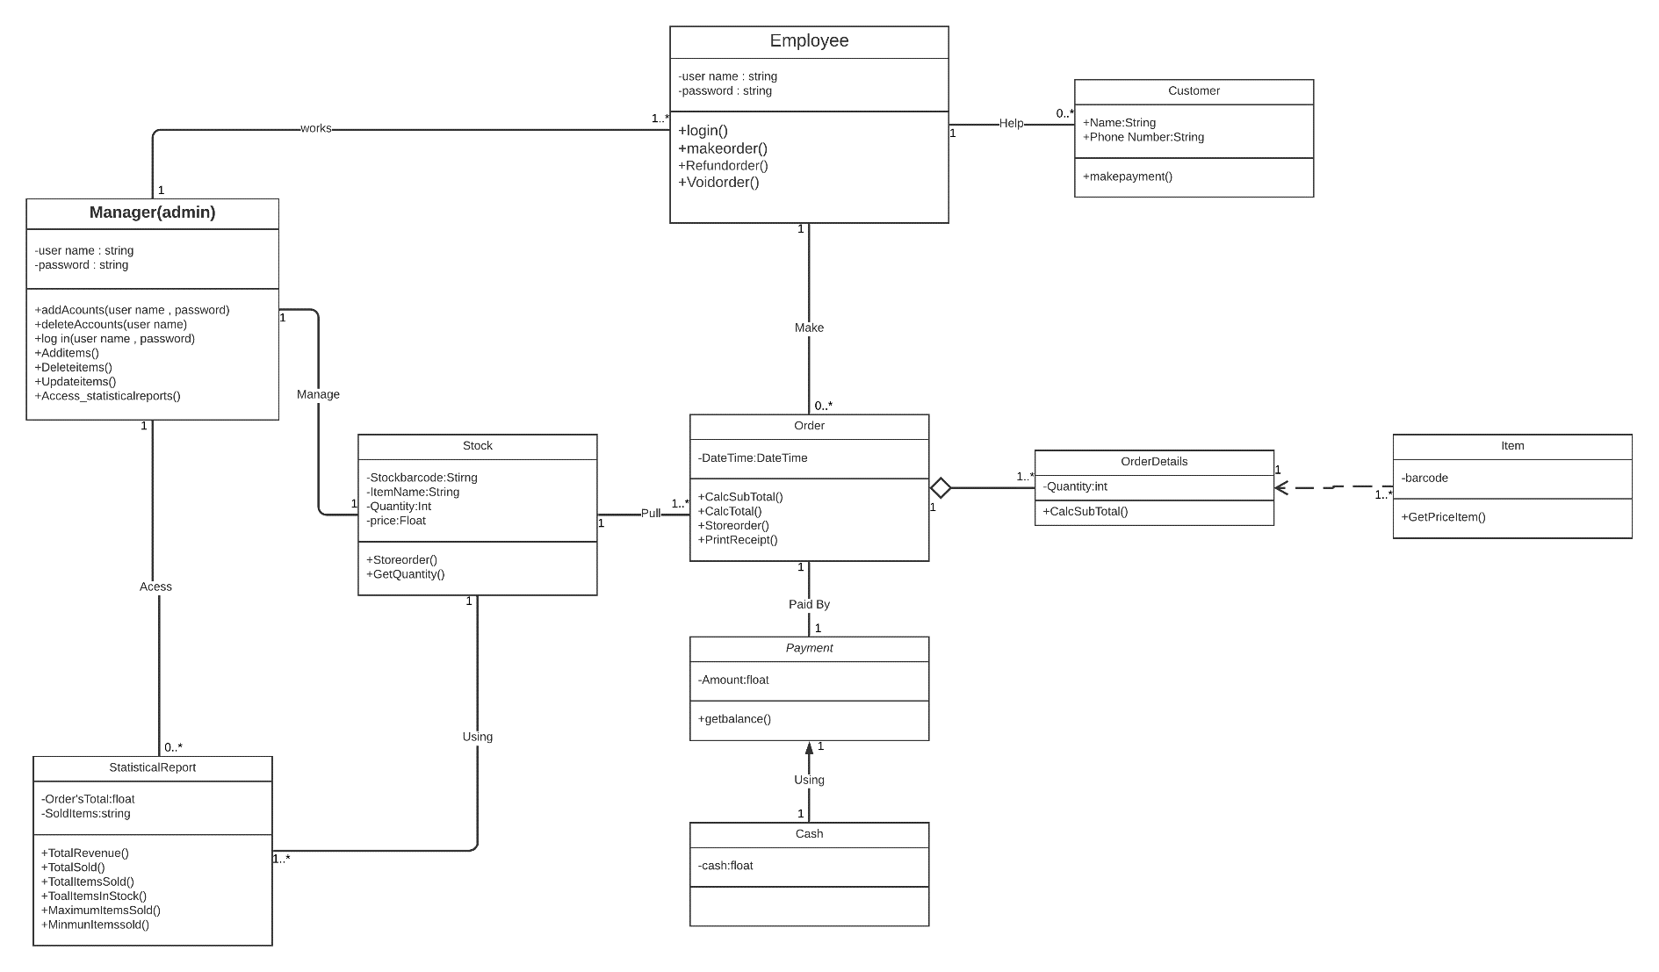

Class id | Class Name | Subsystem id | Description
1 | Manger | None | Add and Block accounts , manage the stock , access to the statistical report
2 | Employee | None | Log in into the system , Make , void and refund order
3 | Customer | None | Pay cash to the employee
4 | Stock | None | Store order and get quantity
5 | Order | None | Calculate total tax , store order , get receipt
6 | Order Details | None | Calculate sub total
7 | item | None | To know item price
8 | Statistical Report | None | Include total ( revenue – sold – items sold – maximum and minimum item sold )
9 | Payment | None | To get balance
10 | Cash | 9 | Customer pays cash to the employee

Scenario of Sequence Diagram
Two sequence Diagram
Sequence Diagram " 1 "
- Actors : Admin
- Object : Interface and System
1 – Admin request system to create an account and choose the account type ( Admin or employee )
2 – System request user name and password to create new account then Admin enter them
3 – System store user name and password in database
4 – Admin need to login , System request user name and password to verfiy them from database “ if username and password is wrong “ system will display error message
5 – System show to admin 3 actions “ Manage Stock , Manage accounts and show statistical report “ and admin choose one
6 – if condition to take action
Sequence Diagram "2"
- Actors : Employee and Cutomers
- Object : Interface and System
1 – employee need to login , system request username and password to verify them from database “ if username and password is wrong “ , system will display error message
2 – customer arrives with items to purchesed
3 – employeee scan items by barcode reader
4 – system return item ( description , total quantity , and price )
5 – interface disply item ( description , total quantity and price )
6 – system calculate total price and interdace display to cutomer and emplyee
7 – customer pays cash and get the receipt included ( price , items name )
8 – end sale

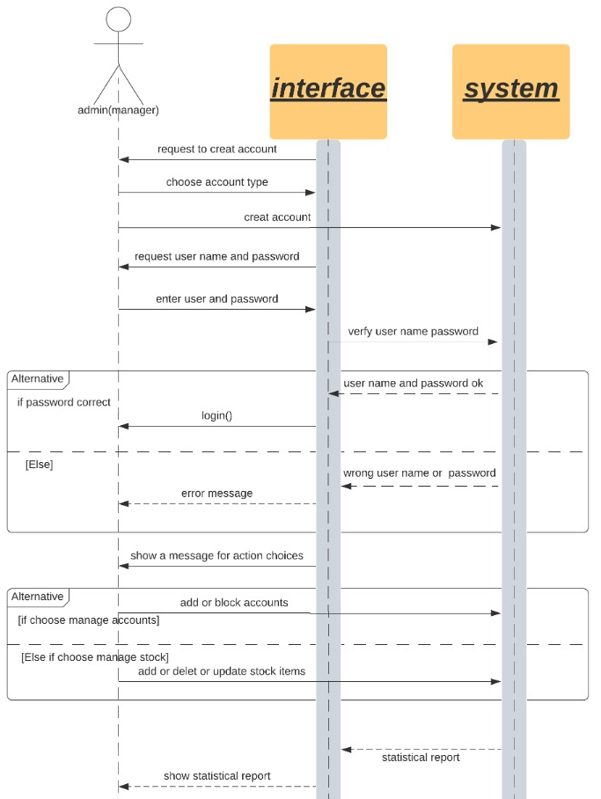
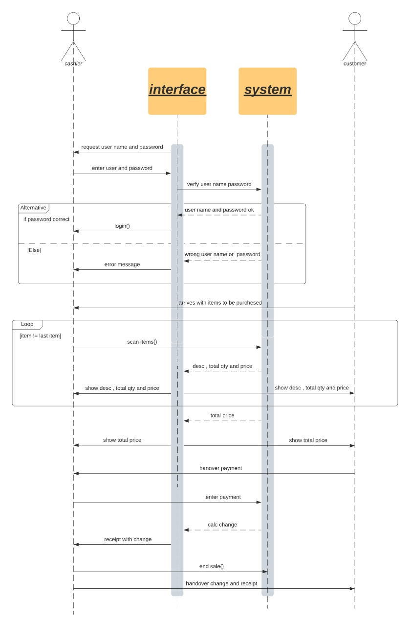
Risk

Risk | Probability
It is impossible to recruit staff with the all required skills for the project | High
Faults in reusable software components have to be repaired before these components are reused. (2). | Moderate
Changes to requirements that require major design rework are proposed | low
The database used in the system cannot process as many transactions per second as expected | high
Hackers can infiltrate network and software weakness setups and steal valuable information, such as cash in our store | low
Didn’t put a password on every device | Moderate
Forget backing up our data | high

11.Test Case
Test id | Test case | Test steps | Test data | Expected result | Actual result | Status
001 | Check create account successful | 1-open POS software 2-choose create account  3-enter data | Username=ahmed  Password=ahmed11 | create Ahmed’s account | As Expected | pass
002 | Check create account failed | 1-open POS software 2-choose create account  3-enter data | Username=ahmedاحمد  Password= | Failed in creating a account | As Expected | pass
003 | Check account Login with valid Data | 1-open POS software 2-choose login  3-enter data | Username=ahmed  Password=ahmed11 | Log in successful | As Expected | pass
004 | Check account Login with invalid Data | 1-open POS software 2-choose login  3-enter data | Username=ahmed  Password=ahmmmm | failed log in | As Expected | pass
005 | Add items with valid data | 1 – open pos system  2 – log in as admin  3 – add items | Id = 1  Name = cd  Price = 2 $  Count = 10 | Added successfully | As Expected | pass
006 | Add items with invalid data | 1 – open pos system  2 – log in as admin  3 – add items | Id = 1  Name = memory  Price = 5 $  Count = 15 | Added failed | As Expected | pass
007 | Delete items | 1 – open pos system  2 – log in as admin  3 – choose item  4 – delete item | User need to choose item | Deleted successfully | As Expected | pass
008 | Update item | 1 – open pos system  2 – log in as admin  3 – choose item  4 – update item | User need to choose item | Updated successfully | As Expected | pass
009 | Make order with valid data | 1 – open pos system  2 – log in as employee  3 – scan item | Scan item by barcode reader | Show price , name , count | As Expected | Pass
010 | Make order with invalid data | 1 – open pos system  2 – log in as employee  3 – scan item | Scan item by barcode reader | Item not exist | As Expected | Pass
011 | Store order with valid data | 1-open pos system  2 – log in as employee  3-make order | Make order using barcode reader | After reading bar code this item count will be decreased from stock and increased in the sold count | As Expected | Pass
012 | Store order with invalid data | 1-open pos system  2 – log in as employee  3-make order | Make order using barcode reader | Item not exist | As Expected | pass
013 | Void order | 1-open pos system  2 – log in as employee  3-make order  4- void order | while processing order customer decided to cancel an item purchase  Action : Employee remove the items from this process | Item not exist | As Expected | pass
014 | Refund order with valid data  (less than 14 days) | 1-open pos system  2 – log in as employee  3-make order  4-end order  5- Refund order | Refund order using receipt’s ID | Id is founded | As Expected | pass
015 | Refund order with invalid data  (more than 14 days) | 1-open pos system  2 – log in as employee  3-make order  4-end order  5- Refund order | Refund order using receipt’s ID | Id is founded but after 14 days | As Expected | pass
016 | Calculate sub total  With valid data | 1-open pos system  2 – log in as employee  3-make order | Make order using barcode reader | Show price for each item | As Expected | pass
017 | Calculate sub total  With invalid data | 1-open pos system  2 – log in as employee  3-make order | Make order using barcode reader | Item not exist | As Expected | pass
018 | Calculate total tax | 1-open pos system  2 – log in as employee  3-make order | Make order using barcode reader | Show price for total items | As Expected | pass
019 | Print receipt | 1-open pos system  2 – log in as employee  3-make order  4-end order | After ending order print receipt | Show id,  Price for each item,  Price for total items,  Date & time | As Expected | pass
020 | Payment | 1-open pos system  2 – log in as employee  3-make order  4-end order | After ending order customer handover cash | Save cash | As Expected | pass
021 | Analysis and statistics report | 1 – open pos system  2 – log in as admin  3- Analysis and statistics report | Admin needs to choose Analysis and statistics report | Show Total Revenue,  Total sold,  Total items sold, Total Items in stock, Max& Min Items sold | As Expected | pass

Test Techniques
Tests will be done by black box techniques
Black box :
ID | Test Technique | Test Case
T1 | Equivalence Partitioning | 001:002  005:015
T2 | Decision Table Testing | 003:004  016:018
T3 | Cause – effect graph | 019

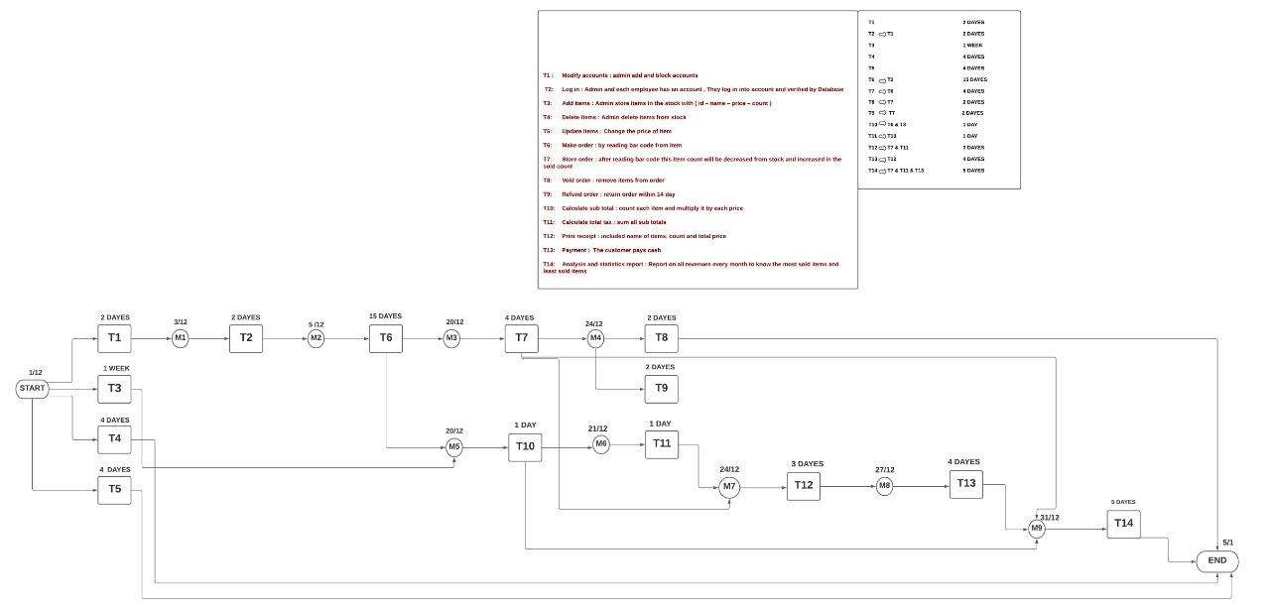
Time
cost
The basic COCOMO model :-
Software | a | b | c | d
organic | 2.4 | 1.05 | 2.5 | 0.38
Semi detached | 3.0 | 1.12 | 2.5 | 0.35
Embedded | 3.6 | 1.20 | 2.5 | 0.32

Our software project is embedded >> why ?

KLOC = 300000 line code
E = a(KLOC)^{b}
Time = c(effort)^{d}
E = 13,453,894,1
T = 477.71
Cost = 28,163,30

